**MPP Final Exam**

**21st June, 2017**

**Dr.Shaqfat Ali Shad**

**Problem 1. (10 points)** Your package Problem1.exam contains three subpackages, **partA, partB** and **partC**. Each contains a designated class file (respectively **PartA, PartB,PartC**), along with (possibly) other classes.

At the top of each of the designated class files, you will see a lambda expression. There are several things you will need to do with this expression.

a. Assign an appropriate type (some functional interface)

b. Express it as a method expression

c. State the type of method expression you have used

d. Express it as an inner class

e. Evaluate the lambda, the method expression and the inner class inside an **evaluator()** method.

There is a main method in each of the designated class files that attempts to run the evaluator method. In the body of the evaluator method, you should test your typed lambda expression, your method reference, and your inner class operation.  
  
Each designated class provides a template for your work. You must follow this template. A sample solution is provided in the package Problem1.sample. Follow the format of this sample very closely.

The lambdas provided in the three parts are:

PartA: (Double x, Double y) -> x * y < x + y

PartB: (CheckoutRecord record) -> record.getCheckoutEntries()

PartC: (Integer key, String value) ->System.out.println("Key:"+ key+" Value:"+ value)

You can not use BiFucntion in this question.

**Problem 2. (10 Points)** In your Problem2 Package you have Employees class with data members in it, Main class has test data and Static function getEmpList. getEmpList is unimplemented and supposed to return Employees in map who have Gender defined as “Male” or “Female”.

You can not define any local variable in getEmpList and must use single stream line to return the result. Test your solution with and without duplicate Employees to deal with expected exceptions.

Your final output should be as without any Compile time and run time error:

Key:???????? Value:Id:????? Name:?????? Age:???? Gender:????????

Key:???????? Value:Id:????? Name:?????? Age:???? Gender:????????

………………………………………………………………………………………………………………………………………………………………………………

………………………………………………………………………………………………………………………………………………………………………………

Key:???????? Value:Id:????? Name:?????? Age:???? Gender:????????

**Problem 3. (10 Points)** In your Problem3 Package you have Students class with data members in it, Main class has test data and Static function getStdList. getStdList is unimplemented and supposed to return Students sorted by their city name and than sorted by their last name in reverse order.

You can not define any local variable in getStdList and must use single stream line to return the result.

Your final output should be as without any Compile time and run time error:

Student:Last name:Mahd First name:Daniyal City:Cedar Rapid

Student:Last name:Lam First name:Joyce City:Cedar Rapid

Student:Last name:Bayed First name:Ayman City:Des Moines

Student:Last name:Adam First name:Yunatan City:Des Moines

…………………………………………

…………………………………………

Student:Last name:Bryen First name:Nicolase City:Kirkwood

**Problem 4. (10 Points)** In your exam package Problme4, there are ClubMemebr class which has all the fields that are associated with Club members, ClubMemebers class is main class and has main method with test code in it. Package has two additional support classes i.e. Tuple2. ClubMember class has signature of two main methods i.e. public OptionalDouble getAverageAge() and public List<Tuple2<ClubMember, ClubMember>> getCouples(), you need to implement these methods using Stream API and test it on the data provided in main method.

You can add additional support method in ClubMembers class to provide the solution. Following is expected output for methods mentioned:

getAvergaeAge(): This gives an average age of Club Members

Average age: 37

classifyMemberships(): This gives list of couples

Couples: [(Mr. Smith, Mrs. Smith ), (Mr. Watts, Mrs. Watts )]

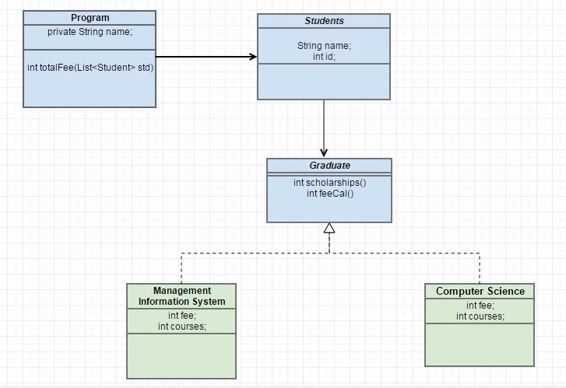**Problem 5. (10 Points)**

UML diagram shows relationship among classes, shell of these classes is given in Problem5.Exam folder. Garduate interface has two functions int scholarships() and int fecal(), where int scholarship() returns scholarship amount for both CS and MIS @ fixed 2500 USD which is non changeable. While int feecal() by default calculates it by formula fee*courses+1000, otherwise for CS it is fee*courses+1500 and for MIS it is fee*courses+1700.

Uncomment code given in the main() available in Program class, you cannot change code in main() as it creates type of Graduate student i.e. Computer Science or Management information Science. You are not supposed to add any further classes beside given in UML, you can add functions in shell as per requirement or can change type of functions as per requirement (instance/static).

**Problem 6. (10 points**) In the code below, you see a method conditionalRemove, which removes from an ArrayList of Strings all those Strings that have length exactly equal to 5. Write the most general possible version of this method.

Things to generalize:

1. From String to the most general type possible

2. From the Predicate type shown in the sample code to the most general type of Predicate (you may need to include a Predicate as a second argument to your conditionalRemove method)

In a main method, show that your conditionalRemove is capable of

A. Removing all Strings in an ArrayList of Strings in which the letter ‘k’ occurs

B. Removing all Employees in an ArrayList of Employees whose salary is < 60,000

C. Remove all Integers in an ArrayList of Integers which are greater than 100

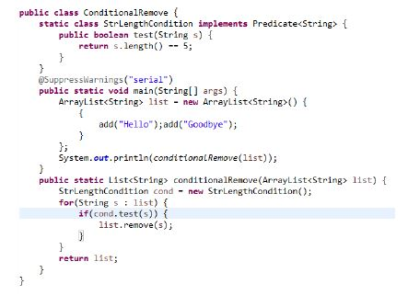

**Problem7. (5Points)** Write a paragraph that link any of the topic we studied during MPP course with SCI.